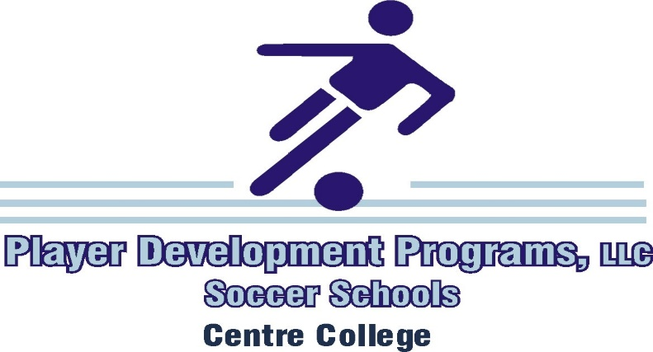

The 32nd Annual Senior School at Centre College, July 11 - 14, 2021

July 11, Sunday
9:30 - 11:00 Residential Camper Registration - Front of Sutcliffe Athletic Center
10:45 - 11:30 Commuter Camper Registration - Front of Sutcliffe Athletic Center
11:45 Mandatory All - Camp Meeting - Front of Sutcliffe Athletic Center
12:00 Safety Review & Team Warm-Up / Keeper Edge Technical Review
12:45 Lunch
2:00 - 3:30 Skill Training & Challenges / Keeper Edge Session
3:45 - 4:45 4 vs. 4 Tournament / Keeper Edge Session
5:00 Dinner
6:00 - 7:15 Game
7:30 - 8:45 Game
9:15 Mandatory All Residential Camper Meeting - Front of Dorms
10:45 Own Room
11:00 Lights Out

July 12, Monday
8:00 Residential Camper Breakfast
9:00 Mandatory All - Camp Meeting - Front of Sutcliffe Athletic Center
9:30 - 11:00 Training Session / Keeper Edge Session
11:15 - 12:00 SSG / Keeper Edge Session
12:15 Lunch
1:15 - 2:30 Skill Training / Keeper Edge Session / Game
3:00 - 4:15 Skill Training / Keeper Edge Session / Game
5:00 Dinner
6:00 - 7:15 Game
7:30 - 8:45 Game
10:45 Own Room
11:00 Lights Out

July 13, Tuesday
8:00 Residential Camper Breakfast
9:00 Mandatory All - Camp Meeting - Front of Sutcliffe Athletic Center
9:30 - 11:00 Training Session / Keeper Edge Session
11:15 - 12:00 SSG / Keeper Edge Session
12:15 Lunch
1:15 - 2:30 Skill Training / Keeper Edge Session / Game
3:00 - 4:15 Skill Training / Keeper Edge Session / Game
5:00 Dinner
6:00 - 7:15 Game
7:30 - 8:45 Game
10:45 Own Room
11:00 Lights Out

July 14, Wednesday
8:00 Residential Camper Breakfast
9:00 Mandatory All - Camp Meeting - Front of Sutcliffe Athletic Center
9:30 - 11:00 Training Session / Keeper Edge Session
11:15 - 12:00 SSG / Keeper Edge Session
12:15 Lunch
1:15 - 2:30 Skill Training / Game
3:00 - 4:15 Skill Training / Game
5:00 Awards Ceremony - Front of Sutcliffe Athletic Center

* Schedule subject to change

www.BurchSoccerCamps.com
Player Development Programs Facebook

