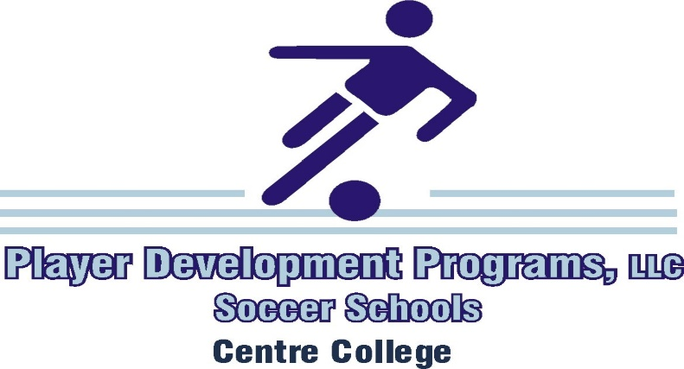

The 32nd Annual Senior School at Centre College, July 11 - 14, 2021

July 11, Sunday
9:30 - 11:00 Residential Camper Registration - Front of Sutcliffe Athletic Center
10:45 - 11:30 Commuter Camper Registration - Front of Sutcliffe Athletic Center
11:45 Mandatory All - Camp Meeting - Front of Sutcliffe Athletic Center

12:15 Safety Review & Team Warm-Up / Keeper Edge Technical Review
C10: 1-3 C9: 4-6 C8: 7 & Keeper Edge C4: 8-10 C3: 11-12 HG: 13-14

1:00 Lunch

2:00 - 3:30 Skill Training & Challenges / Keeper Edge Session
C10: 1-3 C9: 4-6 C8: 7 & Keeper Edge C4: 8-10 C3: 11-12 HG: 13-14
3:45 - 4:45 4 vs. 4 Tournament / Keeper Edge Session
C10: 1-3 C9: 4-7 C8: Keeper Edge C4: 8-11 C3: 12-13 HG: 14

5:00 Dinner
6:00 - 7:15 Game
C10: 10 vs. 11 C9: 12 vs. 13 C4: 7 vs. 14 C3: 1 JV vs. 3 JV
7:30 - 8:45 Game
C10: 5 vs. 6 C9: 3 vs. 4 C4: 1 vs. 2 C3: 8 vs. 9

9:15 Mandatory All Residential Camper Meeting - Front of Dorms
9:30 C10: Teqball Tournament & Pick-Up Soccer
10:45 Own Room
11:00 Lights Out

July 12, Monday
8:00 Residential Camper Breakfast
9:00 Mandatory All - Camp Meeting - Front of Sutcliffe Athletic Center

9:30 - 11:00 Training Session / Keeper Edge Session
C10: 12-14 C9: 9-11 C8: 8 & Keeper Edge C4: 1-3 C3: 4-5 HG: 6-7
July 12, Monday
11:15 - 12:00 SSG / Challenges / Keeper Edge Session
C10: 12-14 C9: 9-11 C8: 8 & Keeper Edge C4: 1-3 C3: 4-5 HG: 6-7

12:30 Lunch

1:30 - 2:45 Skill Training / Keeper Edge Session / Game
C10: 5, 7 C9: 1 vs. 4 C8: 8, 9, 13, 14 Keeper Edge C4: 2 vs. 6C3: 3 vs. 10 HG: 11, 12
3:15 - 4:30 Skill Training / Keeper Edge Session / Game
C10: 5 vs. 7 C9: 8 vs. 11 C8: 3, 6, 10, 4 C4: 9 vs. 13 C3: 12 vs. 14 HG: 1, 2

5:00 Dinner

6:00 - 7:15 Game
C10: 8 vs. 13 C9: 10 vs. 12 C4: 9 vs. 14 C3: 1 JV vs. 3 JV
7:30 - 8:45 Game
C10: 1 vs. 6 C9: 2 vs. 7 C4: 3 vs. 5 C3: 4 vs. 11
9:00 C10 – Teqball Tournament & Pick-Up Soccer
10:45 Own Room
11:00 Lights Out

July 13, Tuesday
8:00 Residential Camper Breakfast
9:00 Mandatory All - Camp Meeting - Front of Sutcliffe Athletic Center

9:30 - 11:00 Training Session / Keeper Edge Session
C10: 5-7 C9: 12-14 C8: 9 & Keeper Edge C4: 10, 11, 8 C3: 1-2 HG: 3, 4
11:15 - 12:00 SSG / Keeper Edge Session
C10: 5-7 C9: 12-14 C8: 9 & Keeper Edge C4: 10, 11, 8 C3: 1-2 HG: 3, 4

12:30 Lunch

1:30 - 2:45 Skill Training / Keeper Edge Session / Game
C10: 9, 10, 11 C9: 1 vs. 8 C8: 2, 3, 12 C4: 6 vs. 7 C3: 4 vs. 5 HG: 13, 14

3:15 - 4:30 Skill Training / Keeper Edge Session / Game
C10: 2 vs. 3 C9: 13 vs. 14 C8: 1, 4, 5, 6 Keeper Edge C4: 11 vs. 12 C3: 9 vs. 10 HG: 7, 8

5:00 Dinner

6:00 - 7:15 Game
C10: 13 vs. 10 C9: 8 vs. 14 C4: 1 vs. 7 C3: 11 vs. 9
7:30 - 8:45 Game
C10: 6 vs. 3 C9: 12 vs. 5 C4: 4 vs. 2 C3:
9:00 C10: Teqball Tournament & Pick-Up Soccer
10:30 Room Inspection – Pack Your Bags!
11:00 Own Room / Lights Out

July 14, Wednesday
8:00 Residential Camper Breakfast
9:00 Mandatory All - Camp Meeting - Front of Sutcliffe Athletic Center

9:30 - 11:00 Training Session / Keeper Edge Session
C10: 2, 3, 4 C9: 5-7 C8: 9 & Keeper Edge C4: 12-14 C3: 10, 11 HG: 8, 1
11:15 - 12:00 SSG / Keeper Edge Session
C10: 2-4 C9: 5-7 C8: 9 & Keeper Edge C4: 12-14 C3: 10, 11 HG: 8, 1

12:30 Lunch

1:30 - 2:45 Challenges / Game
C10: Group A #1 vs. #4 C9: Group A #2 vs. #3
C4: Group B #1 vs. #4 C3: Group B #2 vs. #3
C8: 4 Teams & Keeper Edge
HG: 2 Teams
3:15 - 4:30 Challenges / Game
C10: Group A 1 / 4 Winner vs. 2 / 3 Winner
C9: Group B 1 / 4 Winner vs. 2 / 3 Winner
C4: #9 vs. #10
C3: #11 vs. #12
HG: #13 vs. #14 Futsal

5:00 Awards Ceremony - Front of Sutcliffe Athletic Center
5:15 Camp Release

* Schedule subject to change

www.BurchSoccerCamps.com

Player Development Programs Facebook

Papa John’s: (859) 236-9999
Ask for the Soccer Camp Discount

