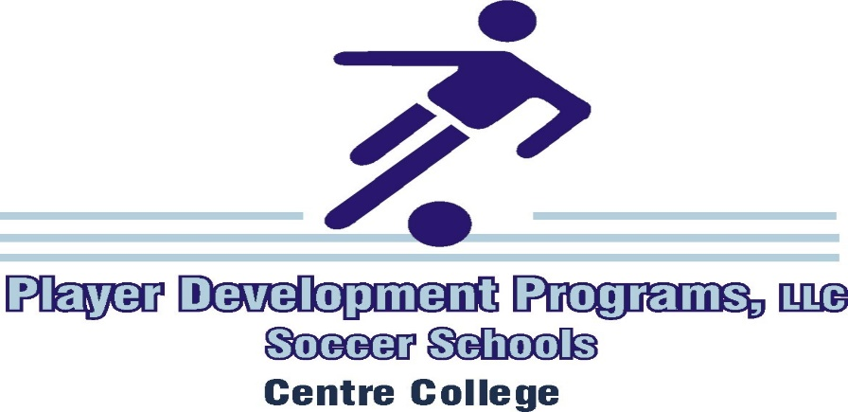
Things To Bring To Camp – Residential Campers
() Sun block & Reusable Water Bottle at night
() Sleeping Bag or Sheets & Blankets (Twin mattress)
() Pillow Case & Pillow
() Towels
() Weeks Worth of Soccer Socks
() Weeks Worth of Underwear
() Athletic T-Shirts
() INDOOR & OUTDOOR Soccer Shoes
() Weeks Worth of Soccer Shorts
() Toiletries (Toothbrush, Shampoo etc.)
() Shin Guards (Mandatory)
() Alarm Clock
() Bag to carry soccer gear
() Fan
() Gold Bond Powder
() Sandals

Things To Bring To Camp – Commuter Campers
() Sun block & Reusable Water Bottle at night
() INDOOR & OUTDOOR Soccer Shoes
() Soccer Shorts
() Shin Guards (Mandatory)
() Bag to carry soccer gear
() Gold Bond Powder
() Sandals

Goalkeepers (In Addition To The Designated Full – Camper / Commuter List)
() Sun block
() Long Sleeve Training Tops (Optional)
() Extra pair of training shorts, socks, t-shirts
() Sliders (for less experienced Keepers)
() Training Pants (for less experience Keepers)
() Goalkeeper Gloves
() Gold Bond Powder
() Sandals
() Shin Guards (Mandatory)

Do not bring large, bulky, or high valued items such as laptops or stereo systems. Centre College and Player Development Programs, LLC, will do everything possible to ensure that each camper is respected along with their belongings. You should not bring items of high value; it only attracts unwanted behavior that we hope to avoid during camp. Centre College or Player Development Programs, LLC, cannot be held liable for stolen or lost property.

While Centre College Resident Halls are air conditioned, often a fan is good to have in the room.

Our Residential campers receive a generous one topping pizza discount with Papa John’s.

